**Tutorial No. 03**

**AIM:** Extending the calculator program to implement trigonometric, statistical and matrix functions.

**THEORY:**

**Trigonometric Functions:**

Math class method is used for Trigonometric function in java. Trigonometric function like cosine, sine hyperbolic sine, arcsine can be used in java using math class methods

Syntax:-

Math.method(Variable)

method can be replaced by any Trigonometric function

**Statistical functions:**

The statistics package provides frameworks and implementations for basic Descriptive statistics, frequency distributions, bivariate regression, and t-, chi-square and ANOVA test statistics.And also for following statistic options:

Descriptive statistics

Frequency distributions

Simple Regression

Multiple Regression

Rank transformations

Covariance and correlation

Statistical Tests

**Matrix functions:**

The Java Matrix Class provides the fundamental operations of numerical linear algebra. Various constructors create Matrices from two dimensional arrays of double precision floating point numbers. Various "gets" and "sets" provide access to submatrices and matrix elements. Several methods implement basic matrix arithmetic, including matrix addition and multiplication, matrix norms, and element-by-element array operations. Methods for reading and printing matrices are also included. All the operations in this version of the Matrix Class involve real matrices. Complex matrices may be handled in a future version.

Five fundamental matrix decompositions, which consist of pairs or triples of matrices, permutation vectors, and the like, produce results in five decomposition classes. These decompositions are accessed by the Matrix class to compute solutions of simultaneous linear equations, determinants, inverses and other matrix functions.

**Class Diagram:**

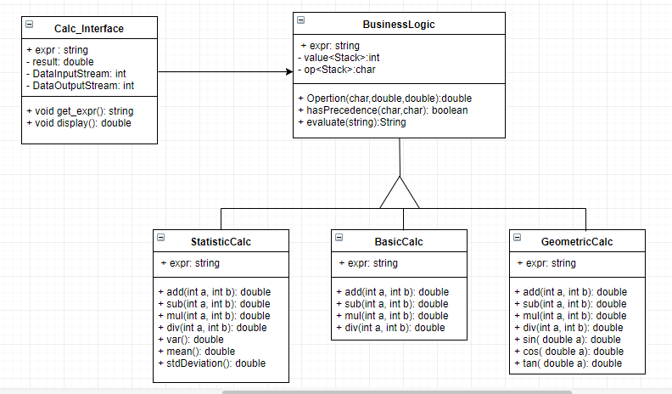

**Conclusion:**

Thus here we have extended the simple calculator to add some functionalities such as trigonometric functions,statistical operations and matrix operations.